**3) Sketches**

**3.1)**

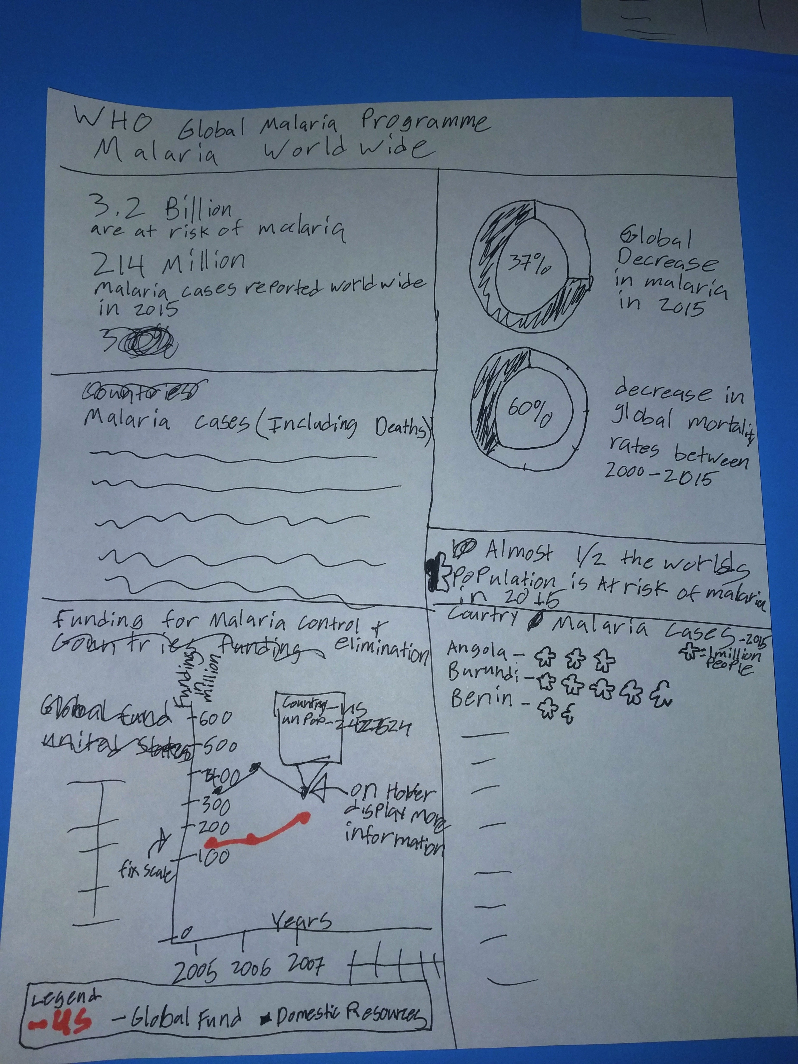

**3.1a) What questions does sketch 1 answer?**

1. What countries have cases of suspected malaria cases vs risk rate?
2. Does the money funded in those areas with a high risk help decrease the cases of malaria?

**3.2 )**

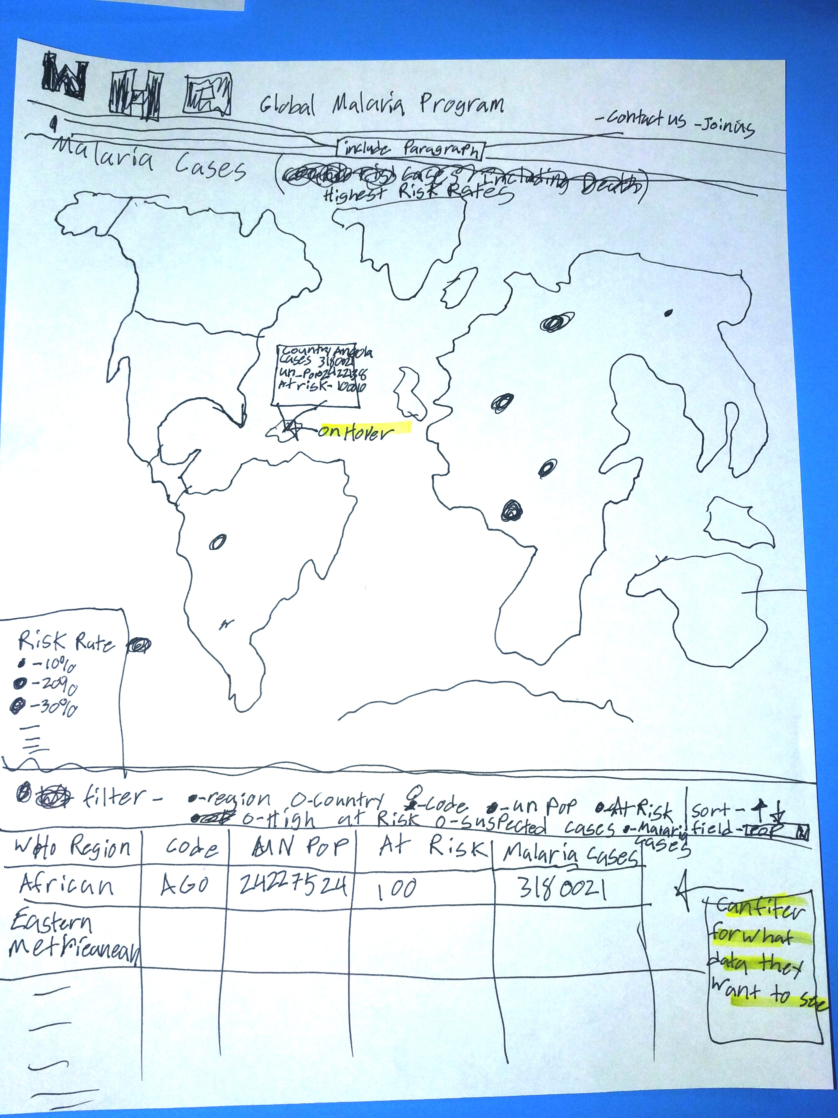

**3.2.a) What questions does sketch 1 answer?**

What countries have the highest risk rates?